Using java Project Hybrid Framework

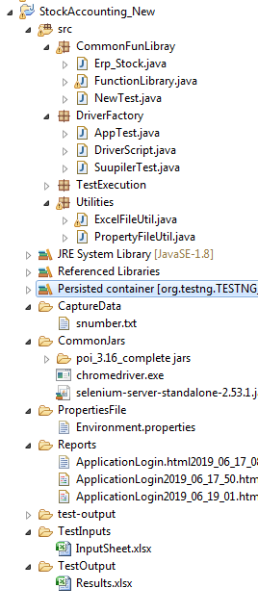

**Using Maven Hybrid Framework and cummber**

